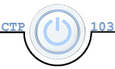

# CTP 103 Course Project Part 5 – PowerPoint Presentation – 50 points

##### Overview

In this part of the project, you will create a 5-minute presentation (less the duration of your embedded YouTube video). You should have a minimum of eight slides. Most the slides will be related to your research paper. In the last slide, you will insert your AACC Savings Chart (not the table) with some comments about it. Online students will add speaker notes to each slide.

##### Section I – PowerPoint Tutorial

Many students have used PowerPoint but there are many features with which you may not be familiar. Review the tutorials below as most are required in the assignment (links take you to tutorials and videos):

1. [Slide Basics](https://www.gcflearnfree.org/powerpoint2016/slide-basics/1/)
   1. Organizing Slides
   2. Customizing Slide Layouts
   3. Customizing Slides – backgrounds and themes
2. [Text Basics](https://www.gcflearnfree.org/powerpoint2016/text-basics/1/)
   1. Select, copy, move, paste, drag and drop text
   2. Format and align text
3. [Applying Themes](https://www.gcflearnfree.org/powerpoint2016/applying-themes/1/)
4. [Applying Transitions](https://www.gcflearnfree.org/powerpoint2016/applying-transitions/1/)
5. [Managing Slides](https://www.gcflearnfree.org/powerpoint2016/managing-slides/1/)
   1. Outline View
   2. Add Slide Notes
6. [Inserting Pictures](https://www.gcflearnfree.org/powerpoint2016/inserting-pictures/1/)
7. [Formatting Pictures](https://www.gcflearnfree.org/powerpoint2016/formatting-pictures/1/)
   1. Crop
   2. Add Border
8. [Aligning, Ordering, and Grouping Objects](https://www.gcflearnfree.org/powerpoint2016/aligning-ordering-and-grouping-objects/1/)
   1. Align Two or More Objects
   2. Alight Objects to Slide
   3. Distribute Objects Evening
   4. Group/Ungroup Objects
   5. Bring Object to the Front or Back
   6. Rotate an object
9. [Animating Text and Objects](https://www.gcflearnfree.org/powerpoint2016/animating-text-and-objects/1/)
   1. Apply animation to an object
   2. Effect Options
10. [Inserting SmartArt Graphics](https://www.gcflearnfree.org/powerpoint2016/smartart-graphics/1/) & [Inserting SmartArt Graphics 2](https://www.youtube.com/watch?v=Xaje8evR-fk)
11. [Insert Video from Embed Code](https://youtu.be/CJRihV458vM)
12. [Inserting an Excel Chart](http://youtu.be/diO--L2jhlg?hd=1)

##### PowerPoint Project requirements

Use the tips in the following articles for your PowerPoint

* [Tips for Effective PowerPoint Presentations](http://www.ncsl.org/legislators-staff/legislative-staff/legislative-staff-coordinating-committee/tips-for-making-effective-powerpoint-presentations.aspx)
* [10 PowerPoint Tips to Make Your Slides More Effective](http://www.ispringsolutions.com/blog/10-powerpoint-tips-to-make-your-slides-more-effective/)

###### Design Template Themes

Design template themes in PowerPoint work the same way they do in Word. They control the color palette, fonts, slide layout, and other elements so that you don’t have to spend as much time formatting your presentation. With certain design templates, you can also choose various theme color schemes. You want to make sure that you choose one that fits with the topic of your presentation.

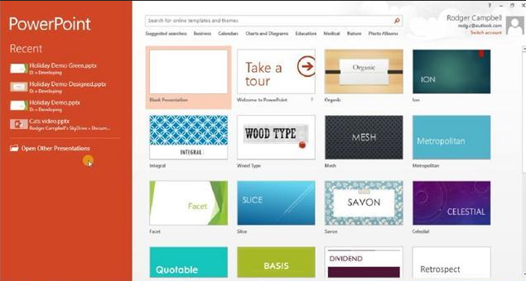

Along with the ones that come with PowerPoint, you can also find free design templates online. Try to find a unique design template for your presentation.

###### Text and SmartArt Graphics

Everyone has been in a presentation where there is too much text on a slide or too many bullets. One way to help with this issue is to use SmartArt graphics. You can either type your bullet points into the SmartArt Graphic or you can convert bullet points.

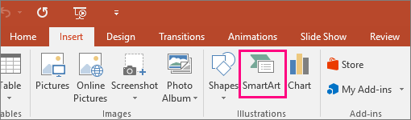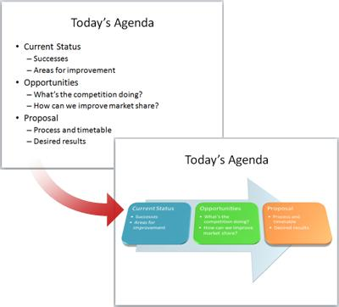

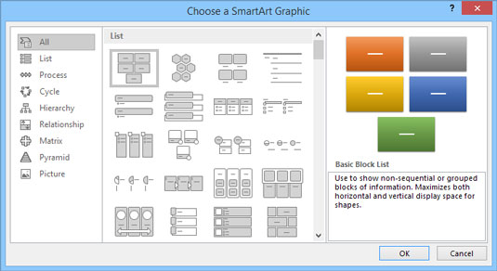

Using the SmartArt Tools contextual tab, you can change layouts, styles, and colors to further enhance the text on the slide. For this assignment, all your bulleted lists should be converted to SmartArt. Some of the layouts also work with pictures. Experiment with different styles to find one that works well with your presentation.

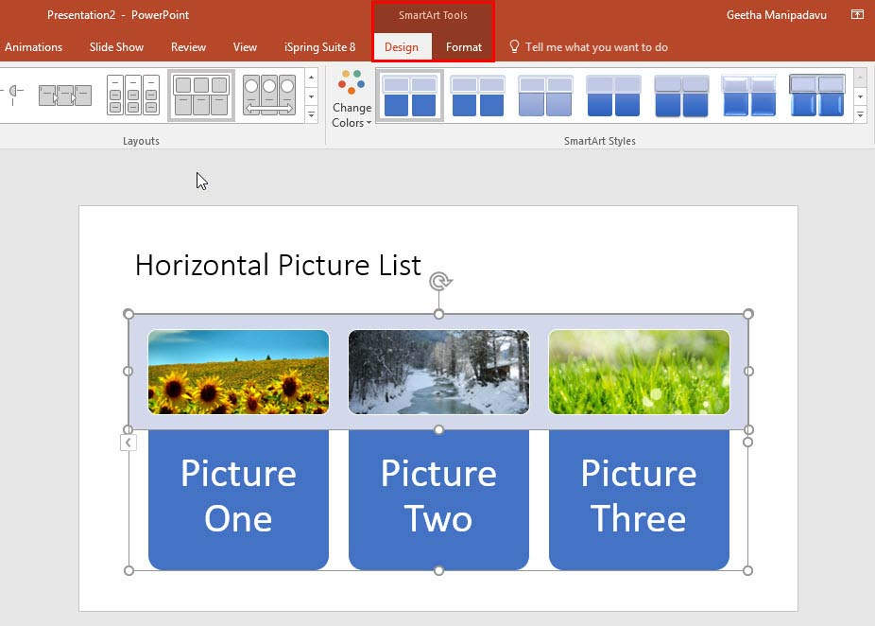

###### Slide Layout

Each design template theme has various layouts to meet the needs of your presentation. It is beneficial to utilize various layouts to add interest to your presentation.

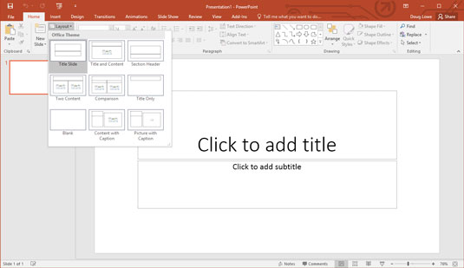

###### Graphics

Images, charts, tables, etc. add interest to a presentation. All graphics need to be of good quality and size and related to the content on the slide. Graphics create an overall theme and make connections that helps the audience understand the concepts. In this presentation, you should have at least three graphics including the AACC Savings Chart from your Excel spreadsheet.

###### Transitions and Animations

In PowerPoint, transitions apply to slides and animations apply to objects or elements on the slide. So, a “fade” transition effect will fade the slide as it moves from one slide to another. The effect is ***between*** slides. A “fade” animation, however, will fade each point on the slide as it plays or each time the Enter Key Is pressed while it is on the same slide. See [this video](https://youtu.be/DNf8aXl2QPg) for an explanation of the difference.

While transitions and animations and be overdone and annoying, they can be effective if used appropriately. For this assignment, apply ONE ***Subtle*** transition to apply to all your slides and apply an ***Entrance*** animation for the points on at least one slide.

###### Inserting a Video from Embed code

Presenters often want to show a part or an entire online video in their presentation. PowerPoint has made this relatively simple to do. Watch the [instructional video](https://youtu.be/CJRihV458vM) on how to do this. To earn the maximum points for this component, you must have a start and stop point in the video (i.e., you will show only a clip of the video) and you should have no suggested videos at the end (note: the instructions on how to do this is in the video).

###### Speaker Notes

When you are creating a presentation, you can add speaker notes that you can refer to later while delivering the slide show to an audience. To access the notes area, you can either click the Notes Page on the View tab or click on “Notes” in the bottom toolbar.

It is important that you do not write paragraphs when you write speaker notes so you are not tempted to read them.

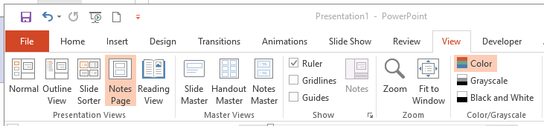

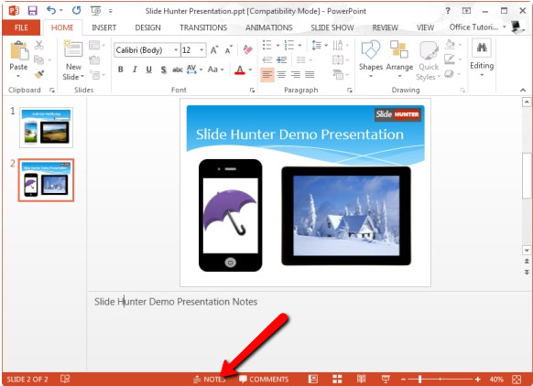

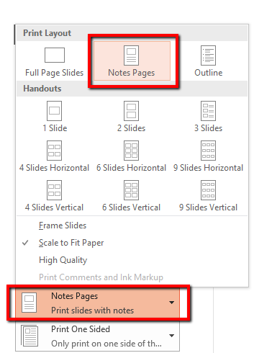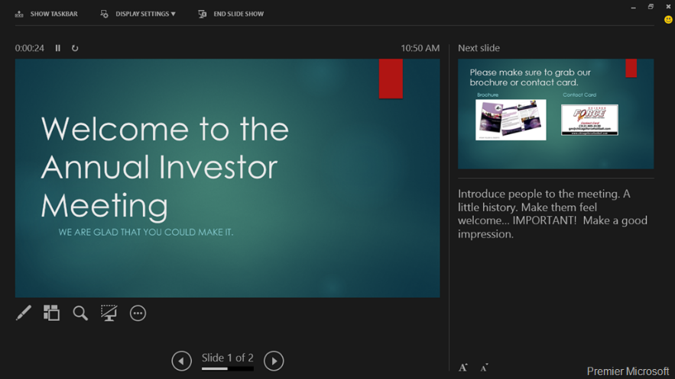Once you have entered your notes, you can print the notes pages or use the speaker display on your computer monitor as you give your presentation (requires a dual monitor or a projector).

|  |  |  |
| --- | --- | --- |
| **Project Part 5 – PowerPoint Rubric** | | |
| Criteria | Description | Points |
| Design Template Theme | Appropriate design template (one for the entire presentation) and does not detract from the presentation. | 5 |
| Text | Font size and style enhance the readability of the content. No distracting text, color, backgrounds, or fonts. No paragraphs or too much text on a slide. | 5 |
| SmartArt Graphics | All slides use SmartArt Graphics (all bulleted text is converted to SmartArt) to enhance the presentation of the text | 5 |
| Slide Layout | Varied use of slide layouts | 4 |
| Graphics | All graphics are related to content and are the appropriate size and good quality. Graphics create an overall theme and make connections that helps the audience understand the concepts. You should have at least three graphics, including the AACC Savings chart. | 5 |
| Transitions & Animations | Apply ONE ***Subtle*** transition to apply to all your slides and apply an ***Entrance*** animation for the points on at least one slide. | 4 |
| Embedded Video | Video embedded on one slide and it plays only a clip of the video with no suggested videos at the end | 7 |
| Speaker Notes | Appropriate speaker notes are on each slide. | 5 |
| Content | Overall content covers the material of the research paper | 5 |
| Writing Mechanics | No errors in grammar, punctuation, or spelling | 5 |
|  | **Total** | **50** |

##### Submission Instructions

Save the file as LastName_PowerPoint.pptx and submit to the dropbox in Canvas by the due date.